The Vast Challege: Overview of the 2015 Challege Mayhem at Dinofun World

Dylan Dias

*Abstract*— In the 2015 Vast Challenge: Mayhem at Dinofun World the participants had to analyze the movements and communication dataset which consisted of nearly 10 million records. They had to solve 3 challenges using the dataset provided to them and had to make sense of the data using visualizations. Each team had their own way of analyzing this data in order to come up with an optimum solution using various graphs, algorithms or even designing their own visualization tool. This paper will provide a brief overview on the analysis techniques used by the top solutions for each challenge, various visual algorithms that have been in their solutions and also analyzing systems implemented.

# **Introduction**

The IEEE VAST (Visual Analytics Science and Technology) is an annual contest in which the contestants are given tasks to solve using various visual analytics tools. The 2015 Vast Challenge was set in an amusement park with rides, restaurants, souvenir and game stores, an arcade, show hall and a performance stage. The dataset included patterns for movements of paying park visitors throughout the park and also communications among pay park visitors, as well as between the park visitor and park services. For mini challenge 1 the participants had to make use of the movement dataset to uncover certain patterns which included activities like creating groups, detecting anomalies etc. For mini-challenge 2 the participants used the communication data to identify the different volumes in communication and they had to even classify these communications into various groups. The way these participants made use of this data was up to them.

The participants had to analyze this data using various visualization, show correlations between them and check for any anomalies that they could find. This meant using only those visualization which could help in making sense of the data. For example, the movement data consisted of the data and time along with the x and y co-ordinates for a many ID’s. Using that they had to trace the entire path used for that those IDs and project it on the park map. This would help them understand what type of person that is whether that person is come to just visit the various attractions of the park, come alone or in a group or is just roaming around in the park. On the other hand, there is the communication data that consists of the overall communication taking place between the visitors of the park which was collected with the help of the park app which the visitors had to use. The park visitors could even communicate with any unknow person by accepting or sending a friend request. This would help in knowing who is communicating with who. By projecting this data, we can get to known which locations the communication is the highest, see various trends in this data or look for various abnormal patterns. Using a combination of both of these datasets can help in giving an overall view of what is happening in the park.

The 2015 Vast Challenges had many submissions. Out of which some were chosen and awarded for the work they had done to come up with a solution. Each team did a comprehensive study of the data and used a different variety of visualization tools. Some participants even created their own systems. These systems had many visual tools built in them which could interact with each to provide more understanding of the data at hand. In a way they made use of different visual analytic algorithms like path finding or brushing. There may be many more different visual algorithms that may have been implemented in the solutions provided which can be analyzed further to see how each visualization has its own benefits in terms of showing detailed patterns, detecting subtle features etc. For the analysis 5 solutions have been selected 2 for mini-challenge 1, 2 for mini-challenge 2 and 1 for grand challenge where there will be a brief explanation of the visual tool that they have designed stating the various parts of the tool, the various visualization algorithms that has been implemented in the solution and their system designs.

# **Challenges**

The challenge included 2 mini-challenges and 1 Grand Challenge. In mini-challenge 1 the participants were given movement data for each paying park visitor over the three-day period using this data they had to use techniques to divide them into various groups and make inferences about these group. Also, they had to keep track of any unusual data patterns.

**Mini-Challenge 1**

1. Characterize the attendance at the park on this weekend. Describe up to twelve different types of groups at the park on this weekend.
   1. How big is the group type?
   2. Where does this type of group like to go in the park?
   3. How common is this type of group?
   4. What are your other observations about this type of group?
   5. What can you infer about the group?
   6. If you were to make one improvement to the park to better meet this group’s needs, what would it be?

Please limit your response to no more than 12 images and 1000 words

1. Are there notable differences in the patterns of activity on in the park across the three days? Please describe the notable difference you see. Please limit your response to no more than 3 images and 300 words.
2. What anomalies or unusual patterns do you see? Describe no more than 10 anomalies and prioritize those unusual patterns that you think are most likely to be relevant to the crime. Please limit your response to no more than 10 images and 500 words.

In mini-challenge 2 they had to make use of the communication dataset. First, they had to identify

the IDs with unusual communication pattern. Second categorize these communication patterns based on any suspicious activity that they can observe. And lastly identify when did the crime occurred.

**Mini-Challenge 2**

1. Identify those IDs that stand out for their large volumes of communication. For each of these IDs
   1. Characterize the communication patterns you see
   2. Based on these patterns, what do you hypothesize about these IDs?

Please limit your response to no more than 4 images and 300 words

1. Describe up to 10 communications patterns in the data. Characterize who is communicating, with whom, when and where. If you have more than 10 patterns to report, please prioritize those patterns that are most likely to relate to the crime.  
   Please limit your response to no more than 10 images and 1000 words.
2. From this data, can you hypothesize when the vandalism was discovered? Describe your rationale.  
   Please limit your response to no more than 3 images and 300 words.

In the Grand challenge participants could use both the data to come up with a solution. The tasks included identifying Scott Jones associates and describing his activities over the three-day period, identifying the park’s main operation issues and giving a description of the crime in detail.

**Grand Challenge**

1. Scott is not a paying customer and does not have an ID. Describe Scott Jones’ activity in the park during the three-day weekend. Who does he spend most of his time with? When does he arrive? When does he leave? What route does he follow?

Limit your response to no more than 10 images and 1000 words.

1. Identify up to 8 issues with park operations during the three-day weekend. Provide a rationale for your answers.  
   Limit your response to no more than 8 images and 800 words.
2. For the crime, describe the following, and provide a rationale for your answer.
   1. When did the crime occur?
   2. Where did the crime take place?
   3. Who are the most likely suspects in the crime?

Limit your response to no more than 5 images and 500 words

# **DATASET**

The datasets included .csv files containing data for 3 days Friday, Saturday and Sunday which included movement and communication data. The data was collected with the help a park app which the visitors used to check-in into rides and allowed visitors to communicate with each other. The movement data was collected with the help of sensors which were placed throughout the park. Along with that the visitors could send and receive messages to each other if they accepted each other’s friend request. This dataset consisted of millions of records of such data.

The movement data was recorded in the following format:

2014-06-06 09:00:07, 53216945, check-in, 71, 98  
2014-06-06 10:00:52, 98376042, movement, 54, 98  
  
Format: timestamp, person-id, type of activity (either “check-in” or “movement”), X-coordinate, and Y-coordinate.

The communication data was recorded in the following format:  
  
2014-6-06 09:45:18, 7268845, 6256281, Coaster Alley

2014-6-08 11:47:10, 3875136, external, Tundra Land  
  
Format: timestamp, from (the sender ID), to (the recipient ID), and location (area where communications occurred).

In the communication data a person with ID 7268845 is communicating with another person with ID 6256281 from the Coaster Alley at 09:45:18AM. A person with ID 3875136 is communicating with someone from outside at 11:47:10AM from Tundra Land.

They have also provided a map of the park which includes pathways which are indicated by red lines, numbering for the different attractions the park has to offer and also free spaces where the visitors can roam freely.

**Map:**

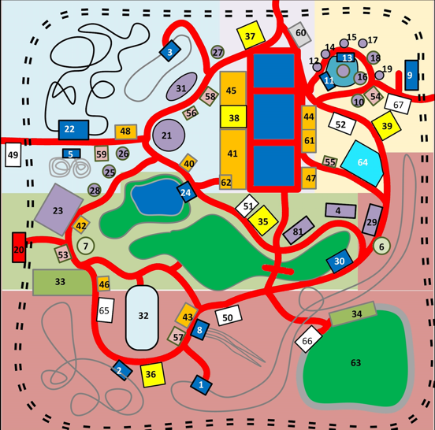

Figure. 1. Map of the park

# **ANALYSIS**

These are the list of colleges that have been selected randomly. This analysis gives a brief overview of the visual tools that they have used or designed.

**Analysis was done on the following solutions:**

Table 1: VAST Challenge Colleges

|  |
| --- |
| **Mini-Challenge 1** |
| **Middlebury College, Award for Integrated Analysis Environment** |
| **Peking University, Honorable Mention for Support for Flexible and Collaborative Analysis** |
| **Mini-Challenge 2** |
| **New York University, Award for Compelling Analysis Supported by Strong Interaction** |
| **Purdue University, Honorable Mention for Compelling Narrative Debrief** |
| **Grand Challenge** |
| **Arizona State University, Award for Outstanding Comprehensive Submission** |

**Mini Challenge 1**

**Middlebury College:**

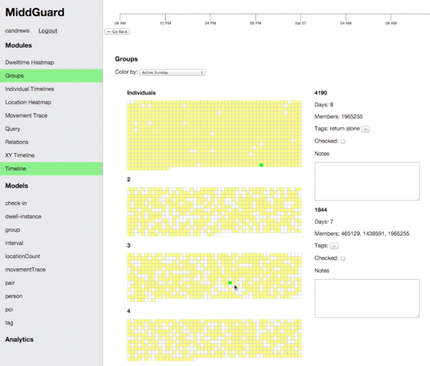

Figure 3. Matrix view of people grouped together having similarities.

In order to solve mini-challenge 1 Middlebury College developed a framework named Middguard which included a set of collaborative multi view analytic tools. This tool included movement trends, location heatmap, a group view, a timeline, location trends and a query interface. They transformed raw movement data into a series of composite forms. For each location they computed the number of occupants for a 30 second interval during the 3-day period.

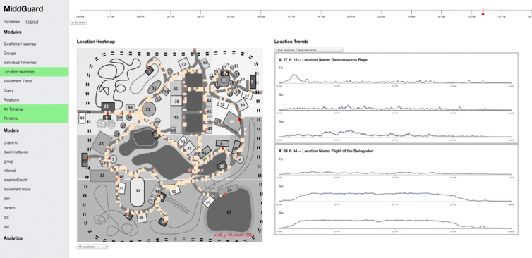

Figure 4. Heatmap of people’s movement

They build a heat map which was used to simulate the movements of people throughout the park this helped in identifying the different points of interest around the park. Through the simulation they created a matrix which kept track on how often people met each other at the park. If anyone spend more than 85% of their time together, they were put in the same group. The group view clustered the group based on their size which on highlighting shows if an individual belonged to a particular group. The timeline stored the timestamp for each individual person which indicated their check-in time at a particular location or the location where the person spends more than 2 minutes. The location trends show the total occupancy for each location in the park for the entire day. Movement trace helped to trace the movements of each individual throughout the park.

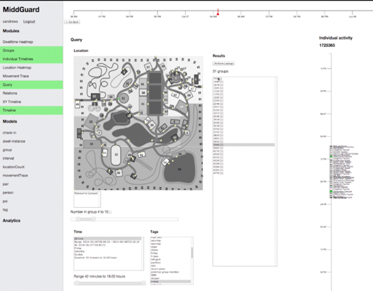

Figure 5. Query Interface

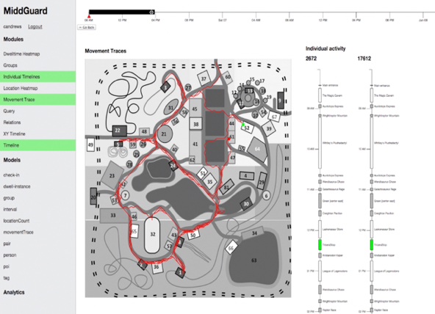

Figure 6. Movement traces and Individual activity timeline

The query interface performed queries based on time, location, group size and group tags. In order to form different groups, they seen the usage for different rides by selecting a particular ride and then using the query interface categorized the group based on their tags.

Using a combination of these different visual tool the participants were able to segregate the data into various groups based on how much time each individual spent with each other and their movements around the park. Each group was then identified, labeled and clustered together. Anomalies were detected using a combination of these visual tools through brushing. The trendline helped in discovering that the vandalism took place 10 am on Sunday morning.

**Peaking University:**

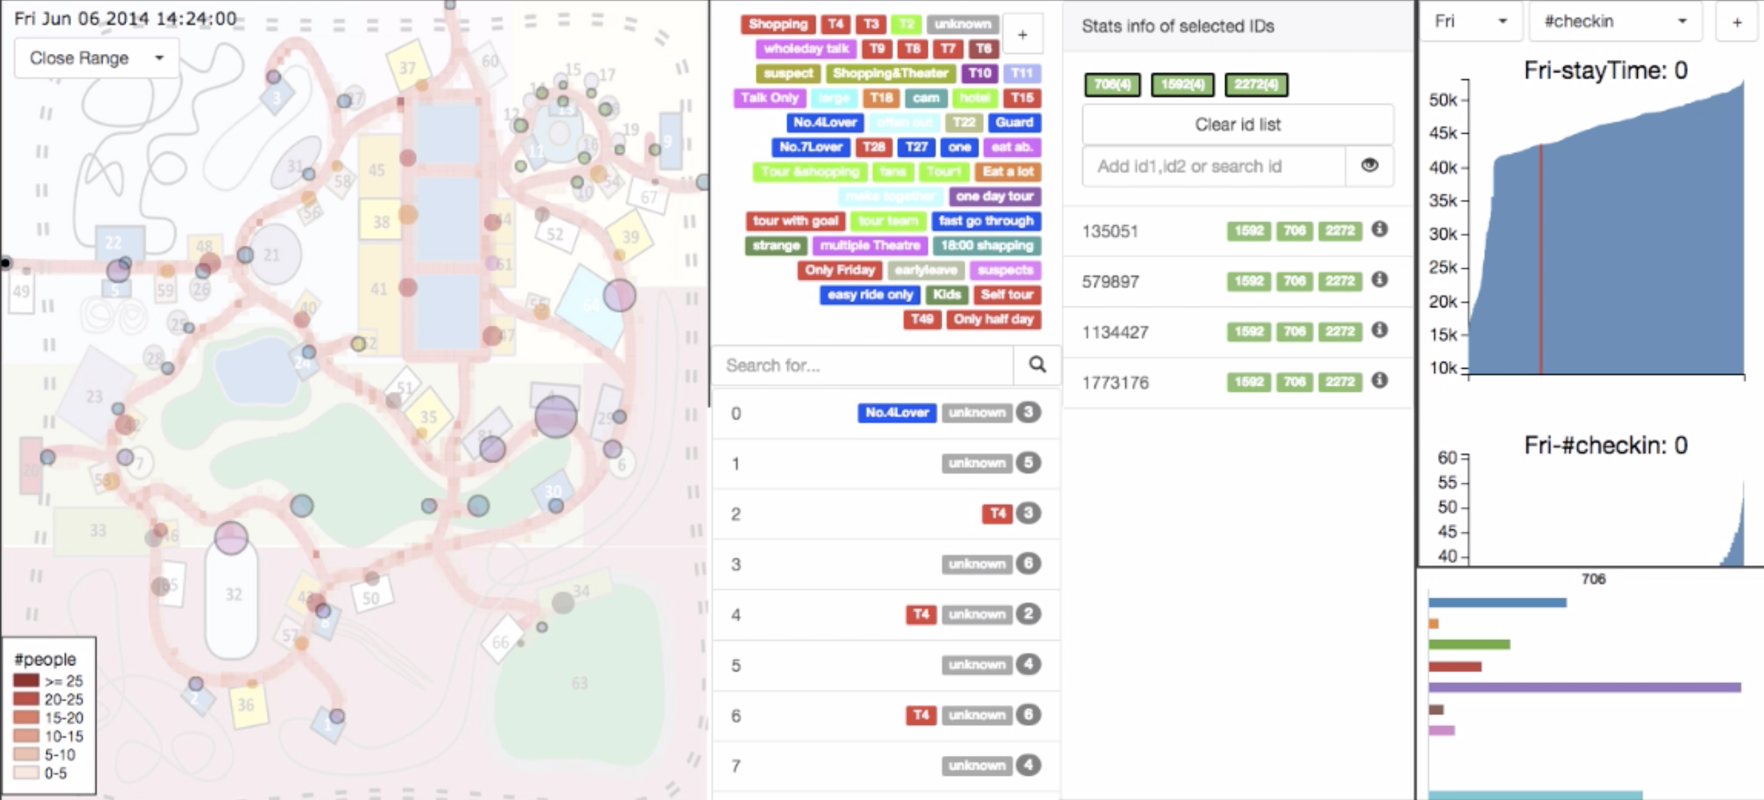

Figure 7. Map view, group list view and attribute filter

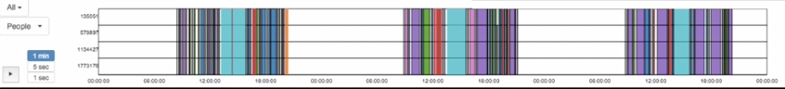

Figure 8. Timeline

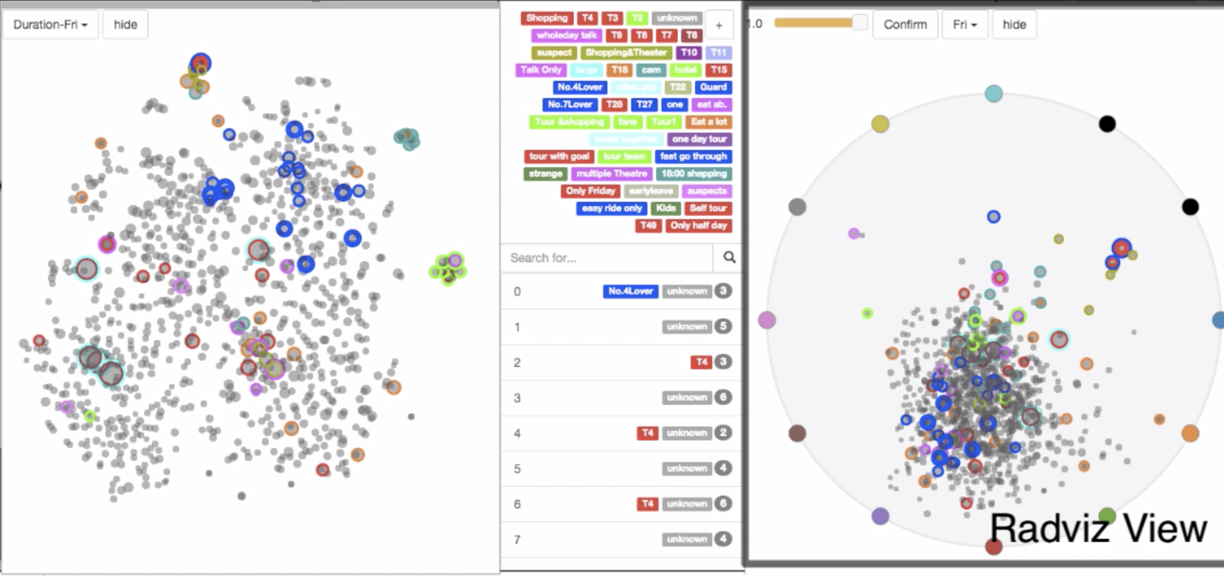

Figure 9. Group view and radviz view

The participants from Peaking developed a visualization tool called PKU Space-Time using python libraries scikit-learn and pandas. This visualization system contains various tools which were used to make sense of the data. It includes a timeline, map view, group list with visitor ID list, attribute filter, group graph view and radviz view. The timeline shows the temporal tread of visitors and places. The map view is used the project the movement of visitors. The group list and visitor list enable users to view individual groups and add annotations. The attribute filter is used to filter data based on their attributes. Group graph view is used to determine which kind of groups are similar based on the time spent at each location. The radviz view given an overall view on which POI the groups are interested in and where they stayed for a long time.

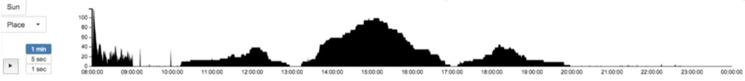

Figure 10. Total occupancy for a selected location

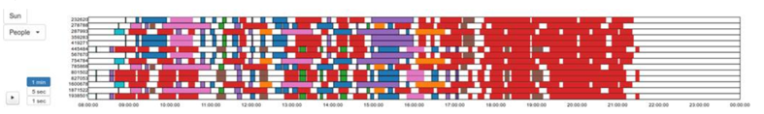

Figure 11. Timeline for each individual ID's

During the data pre-processing stage, they divided the visitors into 3000 groups according to their trajectories along the park. They were able to characterize the attendance at the park using a combination of these visual tools. First, they select a location on the map which on the timeline view show the total occupancy at that selected location for the entire day. Individual days can be selected or for all three days. Figure 9 shows the total occupancy for east gate on Sunday. The timeline can also be used to view the timeline for individual ID’s. Figure 11 show the individual timeline for each individual person. From the timeline they were able to observe different patterns. All these tools are connected to each other through brushing. The group graph view shows whether a group is clustered together if they are these particular groups are assigned labels. This way they were able to create 12 such types of groups.

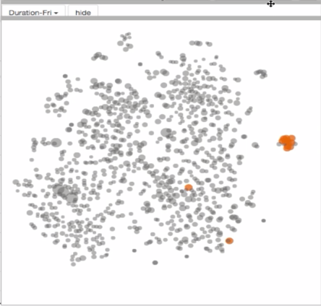

Figure 12. Group graph showing groups that are clustered together.

In another case they adopted the attribute filter to select user according to their attributes for example they filtered users who spend a little time in the park then using the timeline they seen that these visitors stay at the park in the morning and leave in the morning. Using the label, you can create a new type and label the related group. This system helps to analyze the groups with the help of multiple views.

**Mini-Challenge 2**

**Purdue University:**

The participants from Purdue University built a system containing 8 different views. The control panel can be used to filter the data based on time and day selection. It also contains various checkboxes that can be selected which consists of different ways to analyze this data. The map view has two features first it shows kernel density heat maps which helps in identifying hotspots second it can be used to show trajectories of a selected individual further it also can cluster these trajectories together to help discover common movement patterns. The time series view shows the communication frequency of selected people over time. The communication clustering view clusters the people who frequently communicate with each other which is represented with a node link graph where each node correspond a group of people and the links show that there is communication between one or more individuals. The check-in sequence clustering technique clusters the people based on their check-in sequence of attraction that they have visited. The height of which encodes the number of people within the cluster. Each attraction is indicated by a different color. The list view shows the list of users that are communicating with each other. By selecting a user from the list view, it shows the communication frequency from that particular ID.

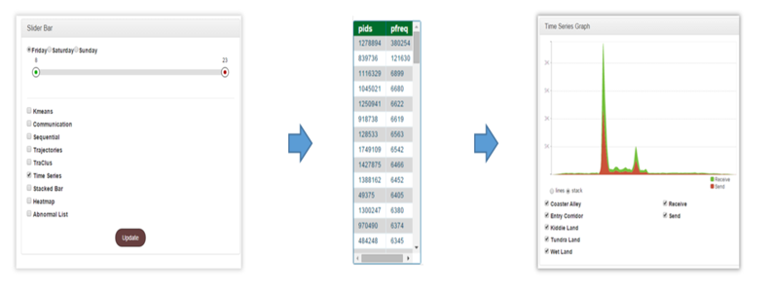

Figure 13. Operation flow of analysis

For example, in figure 13 after selecting the day, checking the time series box and select the duration on the slide bar it gives a list of users with large volumes of communication which upon selecting any user shows that users time-series pattern.

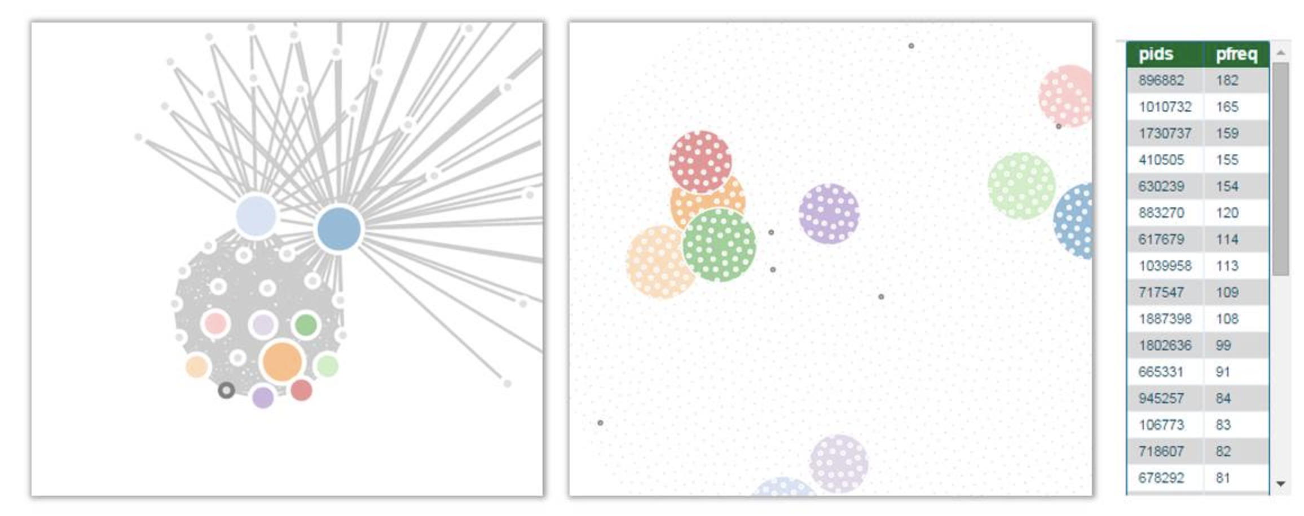

Figure 14. Cluster of people that travel separately but still send messages to each other.

From the above figure it is seen that there are many communication patterns between small groups where each group is indicated by a node. On selecting a node, it shows the travel sequence of these groups and the list of ID’s for that selected cluster.

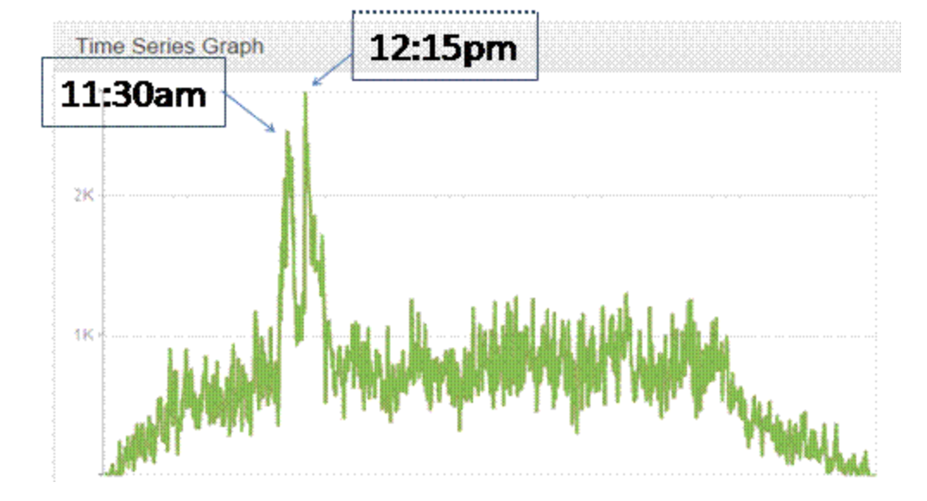

Figure 15. Communication pattern for Sunday

Figure 15 shows the total messages sent in the park on Sunday. In order to determine when the crime occurred, they began to view the total messages sent from the park for each day of the weekend. From the time series graph it was seen that there were similar patterns throughout each day except Sunday as the was a huge spike in communication in different areas of the park on that day. Which indicated that the crime took place between 11:30am and 12:15pm on Sunday.

**New York University:**

The participants from New York University built an AD-hoc web application to solve the challenge. In the data pre-processing stage, they placed the ID’s into groups based on their movement patterns and assigned ID’s to those groups. This system consists of 7 major components namely 2-level timeline, select and target list, communication view, map view, facility percentage table, facility sequences and charts. The timeline can be set to view a single time point or set to a time range in order to analyze the activities at that time. The timeline also has a scene playback option to view movement patterns over a specific period of time. There is the select and target list where the select list holds tentatively users selected group and the target list holds the list of identified target groups that needs to be traced. Based on the ID’s in the list the visualization change for those ID’s only. The communication view transforms the communication messages into a node link diagram where each node represents a group and the lines between nodes indicate that those groups are communicating with each other over a chosen time period. The communication view can be incorporated into a map to show the locations from which the communication is taking place or a heatmap to show the volume in the communication. The facility sequences show the facilities each group visited which is ordered by time and the color represents the type of facility. This helps in identifying which parts of the park important communication is taking place. The facility percentage table show the time spent by the groups at each facility. This can help to identify the type of group. The charts show various information like the message volume for sent and received messages throughout time for each group. It is also helpful in processing analytical information. The map view makes use of movement data by selecting certain points on the map it shows the information on the other views for those targeted groups. This helps in giving a detailed analysis on the data. There is also a global filter to analyze only targeted groups. The group can also be expanded to view the ID’s it holds to help in further analysis. This system offers a comprehensive data analysis using various approaches.

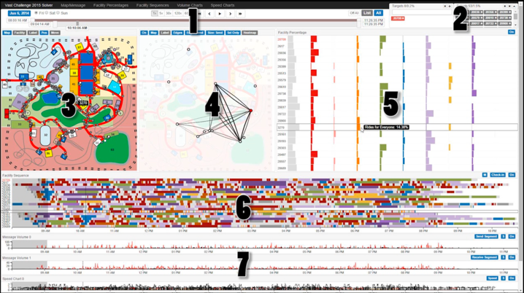

Figure 16. 1) 2-level timeline 2) Select and Target list 3) Map view 4) Communication view 5) Facility percentage table 6) Facility sequences 7) Charts

**Grand Challenge**

**Arizona State University:**

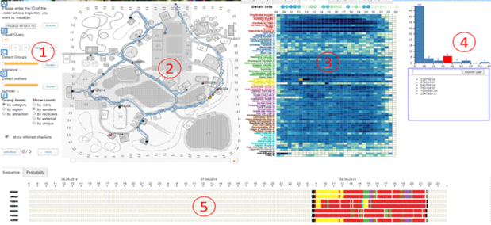

Figure 17. Exploratory view 1) Visual query tool 2) Map view 3) Calendar view 4) Distribution view 5) Trajectory view

The participants from Arizona State University built a system containing two views to solve this challenge. The exploratory view and the report view. The exploratory view consists of a control panel which can be used to cluster spatial and temporal trajectories [6]. A map view to display movement of people around the park. A calendar view to show ride attendance for each day or they can be aggregated together. The rows indicate all the rides and column represent number of people that have check-in into the ride. The calendar view helps to give an overview of the activities going on in the park. Like when the restaurants are opening and other attractions timelines. A visual query tools help in performing Boolean operations by selecting points on the calendar view. After running the Boolean operation, we get a list of ID’s in the trajectory view which on hovering over shows their path traveled along the park where each color represents different areas of the park. There is a distribution view that creates a histogram for the number of sent/received/external messages during a time period.

From figure 18 it can be seen that by selecting blocks on the calendar view for the Grinosaurous stage and running it on the visual query tool it shows the list of ID’s involved at that period of time in the trajectory view. It then shows the trajectory view of all the ID’s involved at that period of time. This was used to hypothesize the trajectory of Scott’s movements.

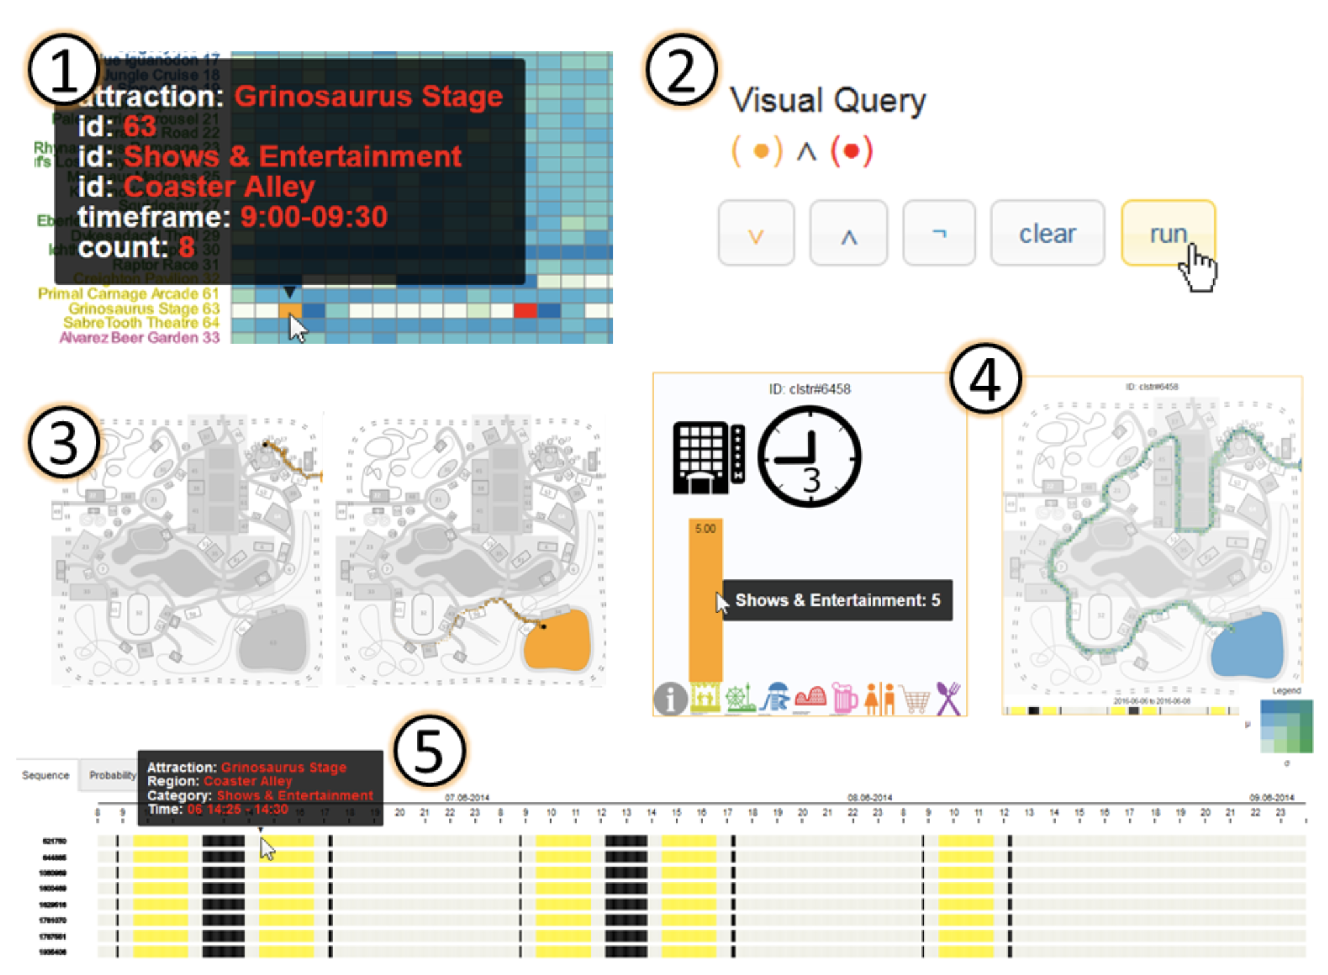

Figure 18. Track Scott's entourage movements

They used the calendar view to address many issues of the park and also determined the route that is mostly used by Scott and his entourage.

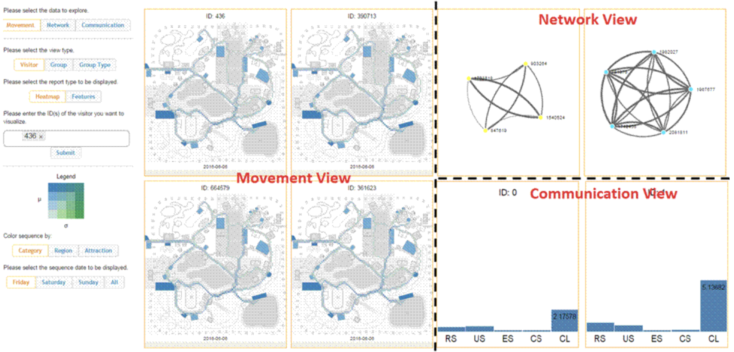

Figure 19. Report View

The report view is mostly for analyzing communication data. In this view you can enter the ID’s and group whose communication patterns you want to visualize.

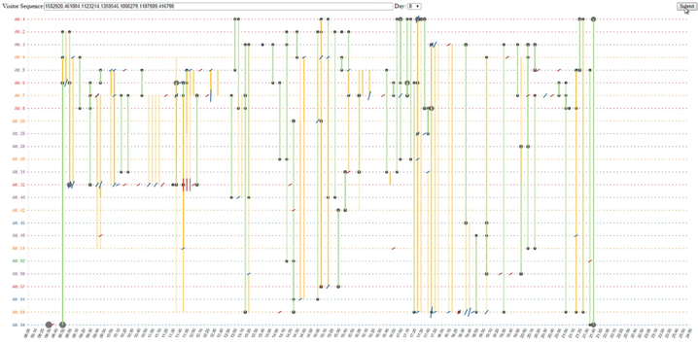

Figure 20. Communication Map

There is also a communication map which is used to show the communication pattern between different ID’s. Figure 20 represents the communication map where each group ID’s are represented with a circle where the circle size indicates the number of ID’s present at that location. The y-axis is the attraction number and the x-axis is time. Large circles can split into smaller circles which indicate some ID’s have left the group or new groups are formed. Yellow lines show that communication is taking place between 2 groups, green line shows that a group is moved to another location, red hashes represent external communication and blues hashes indicate communication within groups.

# **VISUAL ALGORITHMS IMPLEMENTED**

These were the following visual thinking algorithms which were used to come up with the solutions. These algorithms were used as they were best suited to make sense of the data that was provided.

**Algorithm 1: Pathfinding on a Map**

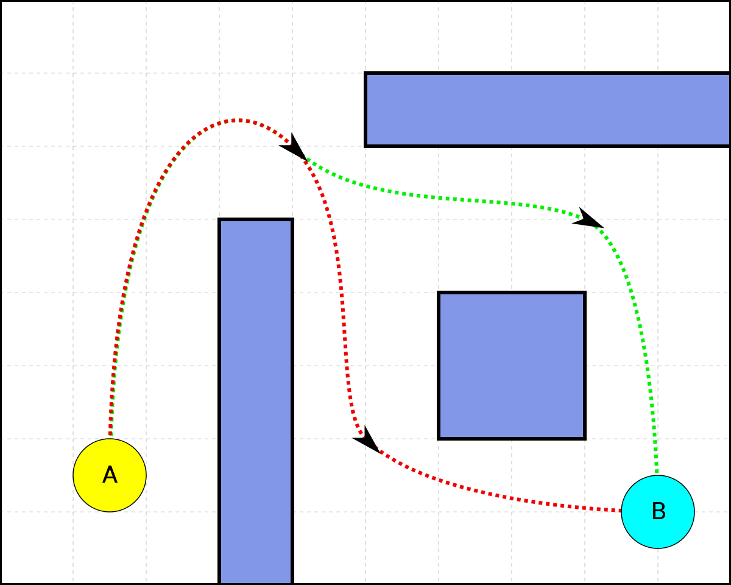

Figure 21

The path finding algorithms helps in tracing out the path that an individual node uses. From figure 20 it can be seen that in order to get from path A to& path B it traces the best route possible which is indicated by the dotted lines. From each individual persons ID and the movement data given we can trace the movements of each person and based on their movement around the park we can segregate them into different groups of people which can helped in explaining their behavior [2].

**Algorithm 2: Brushing**

Figure 22

Brushing mainly involves relating different graphs with each any information highlighted in one part of the graph must be reflected in other graphs too. Almost all the submissions had implemented brushing in their solutions as this is an effective way to analyze data. Highlighting the information that is relevant and then viewing that data in many different views helps in detecting abnormalities in the data.

**Algorithms 3: Finding Local Patterns using Degree-of-Relevance Highlighting**

In degree of relevance highlighting the main task is to see if things are interrelated as they might be highly relevant. For example, in this challenge the participants were asked to track Scott’s (Celebrity) movements but Scott didn’t have any ID. So, in order to determine Scott’s activities throughout the park, they had to identify his associate’s ID’s. Also, this algorithm was used to determine the ID’s of the suspects that were involved in the crime.

**Algorithm 4: Visual Queries**

Query refer to the action of retrieving a certain amount of data [5]. Some solution has embedded a query interface tool in them which have many uses like retrieving ID’s that share the similar interest and creating groups out of them.

**Algorithms 5: Analytic Framework**

Mostly all the solutions have built a framework which helps in viewing the datasets to make more sense of the data [5]. The framework built is mostly based on the task at hand. Since this task is mostly based on analyzing movement and communication data there was more use maps and timelines.

**Algorithm 6: Visual Monitoring**

In visual monitoring as the name suggest is to keep track of various trends or patterns emerging from the data. The participants made use of timelines in their solution to check for any suspicious activities going on at a particular time. This need them to keep an eye out for abnormal patterns the data.

**Algorithm 7: Lateral Exploration**

At times there is a certain piece of information that needs to be followed to check for any links. In this case using the communication data they had to find the suspects involved in the crime. For this they had to view the communication patterns between various ID’s. Once the suspect ID has been found it can be used to link it to all the other suspects.

# **SYSTEM DESIGN**

Table 2: Systems used by Colleges

|  |  |
| --- | --- |
| **Mini-Challenge 1** | |
| Middlebury College | Middguard |
| Peking University | PKU Space-Time explorer |
| **Mini-Challenge 2** | |
| New York University | Ad-hoc System |
| Purdue University | Custom System Design using Tableau, R |
| **Grand Challenge** | |
| Arizona State University | Custom System with 2 views |

All of these systems had certain things in common when it came to analyze the data. For example, each system had implemented a park map and traced the movement of each visitor throughout the park. This gave them an idea of the various types of visitors visiting the park and helped them to segregate them into various groups. Another thing common in all of these system designs was the use of timelines. This helped in analyzing the data in detail. Like for checking for anomalies, detecting certain patterns in the data. Brushing was something common in all the systems. Being able to view and analyze specific data makes the sense making process easier. The participants from Middlebury college and Arizona State University implemented a query interface tool in their systems. This tool would perform query operations based on the attributes selected. New York University and Purdue University both created a group view in which they clustered the groups with similar interest together. These clusters provided a way to see which groups are communicating with each other. They both implemented a node-link graph where each node would represent a group and the nodes were connected to another node only if they were communicating with each other. This would help them to analyze the various types of communication taking place throughout the park. The systems designed for mini-challenge 1 Middguard and PKU Space-Time explorer mostly focused on analyzing movement data. Both of these systems were able to trace the path an individual ID followed using the coordinates. And then timelines were created to show the paths mostly used by an ID. On the other hand, Ad-hoc system and Custom systems designed by Purdue University and Arizona state university incorporated the use of both the communication and movement data.

# **CONCLUSION**

Throughout the year the participants have been asked to analyze various different types of data. The 2015 Challenge involved movement and communication data. In order to come up with a solution each participant used various visual thinking algorithms and a variety of visual analytic software’s available at their disposal. Addressing each problem with the help of specific graphs which helped in making more sense of the data. The VAST Challenges are a way of exploring the vast fields of the visual analytics world through a series of challenges. With each passing year these challenges are evolving with an increase in the complexity of the problems.

**REFERENCES**

1. W. Cui, "Visual Analytics: A Comprehensive Overview," in *IEEE Access*, vol. 7, pp. 81555-81573, Jun 2019.
2. Natalia Andrienko and Gennady Andrienko, “Visual analytics of movement: An overview of methods, tools and procedures”. *Information Visualization*, pp.3-24, Jan. 2013.

1. Guo-Dao Sun, Ying-Cai WU, Rong-Hua Liany and Shi-Xia Liu. “A survey of visual analytics techniques and applications: State-of-the-art research and future challenges.” *Journal of Computer Science and Technology*, *28*(5), pp. 852-867, Sept 1. 2013
2. Santhi, K. and Reddy, Rama Mohan. “Critical Analysis of Big Visual Analytics: A Survey.” *IADS International Conference on Computing*, *Communications & Data Engineering (CCODE)*, Available at SSRN: <https://ssrn.com/abstract=3200438> [Feb 7. 2018].
3. Colin Ware, William Wright and Nicholas J Pioch. “Visual Thinking Design Pattern.” *In DMS*, pp 150-155, Aug 8. 2013
4. Visual Analytics Benchmark Repository, <https://www.cs.umd.edu/hcil/varepository/benchmarks.php> . Accessed 2020-07-25